**The Battle of the Neighborhoods - Report**

1. **Introduction & Business Problem :**

The City of New York, is the most populous city in the United States. It is diverse and is the financial capital of USA. It is multicultural. It provides lot of business oppourtunities and business friendly environment. It has attracted many different players into the market. It is a global hub of business and commerce. The city is a major center for banking and finance, retailing, world trade, transportation, tourism, real estate, new media, traditional media, advertising, legal services, accountancy, insurance, theater, fashion, and the arts in the United States. This also means that the market is highly competitive. As it is highly developed city so cost of doing

business is also one of the highest. Thus, any new business venture or expansion needs to be analysed carefully. The insights derived from analysis will give good understanding of the business environment and the Return on Investment will be reasonable.

**Business Problem**

The City of New York is famous for its excelllent cuisine. It's food culture includes an array of international cuisines influenced by the city's immigrant history.

Indian food have become so popular in the United States now it seems that there is one on every corner, not only in major cities but also in smaller cities. Starting a sushi restaurant can be a great business opportunity, but you need to distinguish yourself from others to enjoy long-term success.

If you plan a real restaurant that can demand higher prices for authentic indian food, focus on neighborhoods and outlets that already attract a sophisticated client. If you plan a cheap buffet restaurant, points to the masses looking for affordable high-traffic locations with large shopping centers and other local points of interest. So it is evident that to survive in such competitive market it is very important to startegically plan.

Various factors need to be studied inorder to decide on the Location

My Client wants to open his business in Manhattan area, so I only focus on that borough during my analysis. The objective is to locate and recommend to the management which neighborhood of Newyork city will be best choice to start a restaurant. The Management also expects to understand the rationale of the recommendations made.

This would interest anyone who wants to start a new restaurant in Newyork city.

1. **Data**

**Data 1:** Neighborhood has a total of 5 boroughs and 306 neighborhoods. In order to segement the neighborhoods and explore them, we will essentially need a dataset that contains the 5 boroughs and the neighborhoods that exist in each borough as well as the the latitude and logitude coordinates of each neighborhood. This dataset exists for free on the web. Link to the dataset is: https://geo.nyu.edu/catalog/nyu_2451_34572

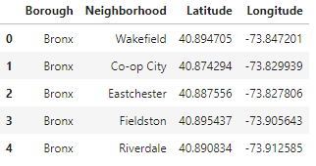

**Data2:** Newyork city geographical coordinates data will be utilized as input for the Foursquare API, that will be leveraged to provision venues information for each neighborhood.We will use the Foursquare API to explore neighborhoods in New York City. The below is image of the Foursquare API data.

In addition, Sushi category Id 4bf58dd8d48988d1d2941735 is used for retrieving data from Foursquare API.

1. **Methodology**

In this project, I will use the basic methodology as taught in Week 3 lab.

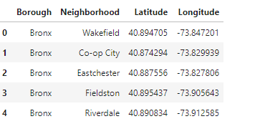

Above, I have done convert addresses into their equivalent latitude and longitude values. Then we will use the Foursquare API to explore neighborhoods in Manhattan, New York. After that, explore function to get indian restaurant categories in each neighborhood.

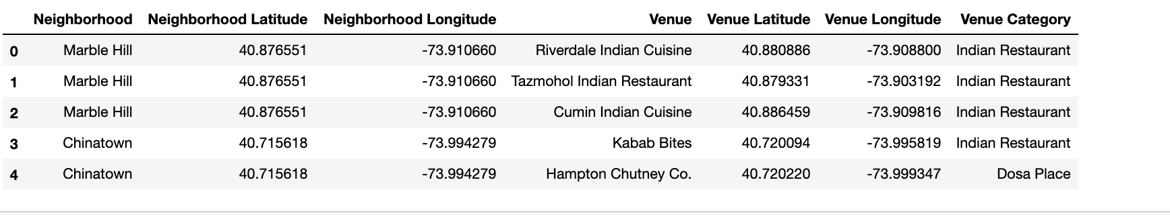

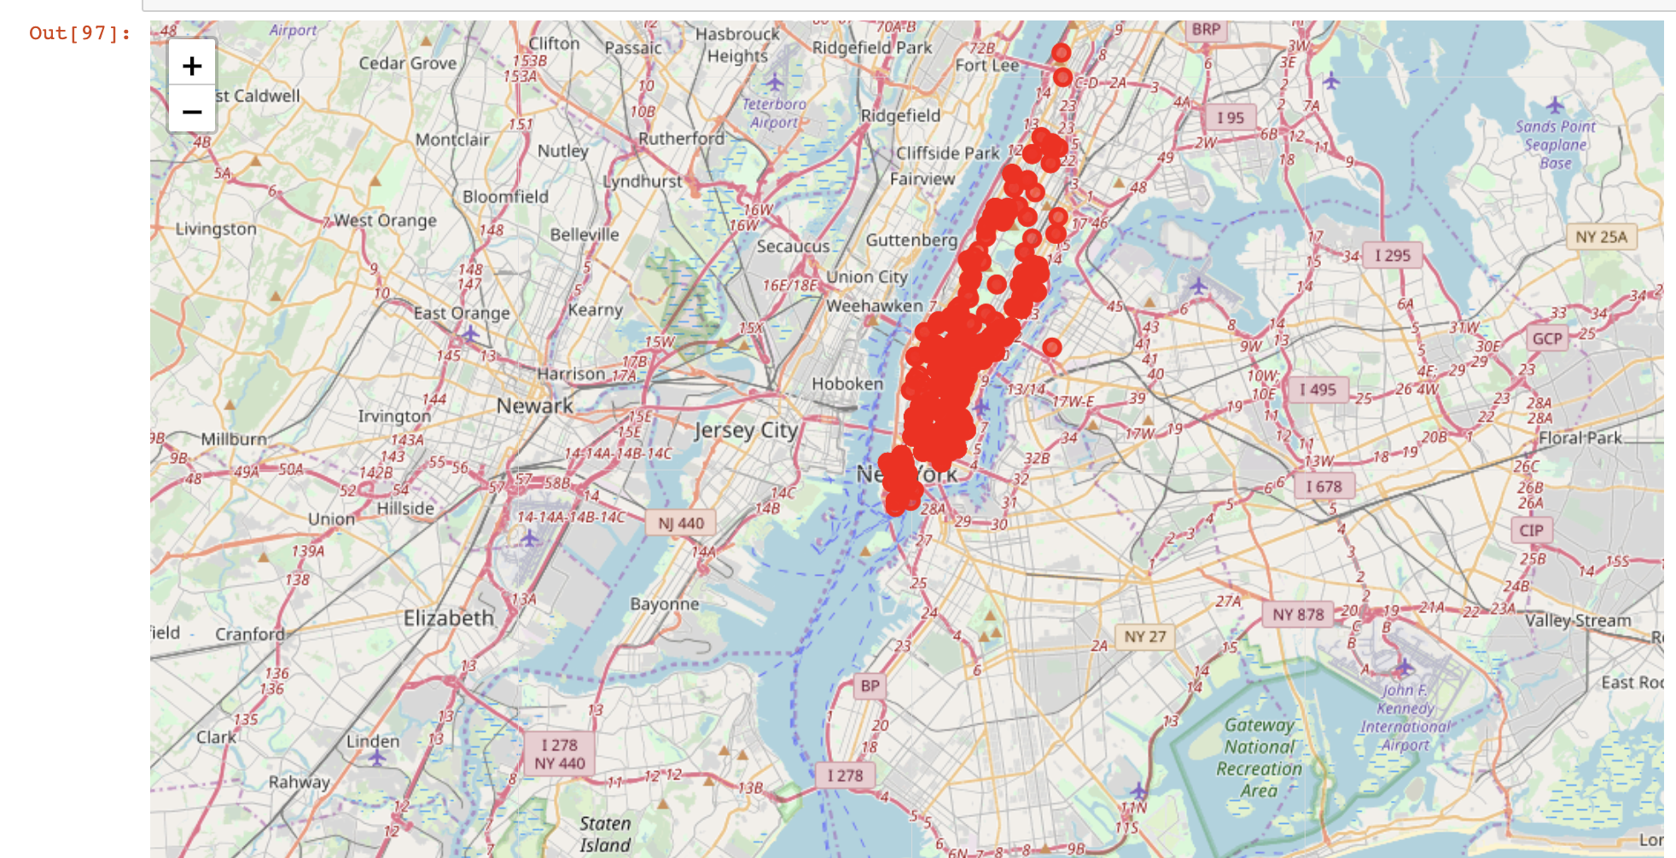

Indian restaurant in Manhattan

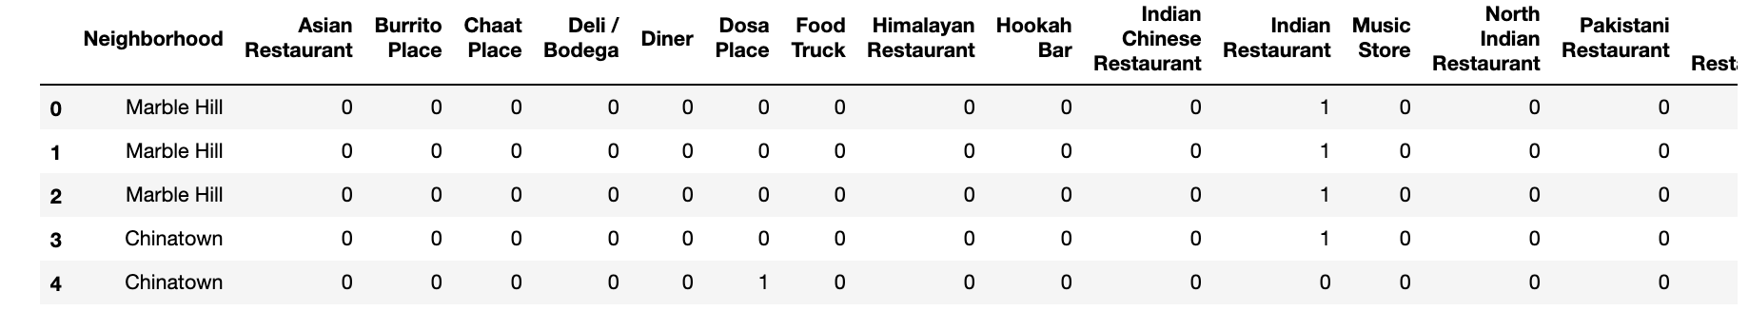

Then use this feature to group the neighborhoods into clusters K-means clustering algorithm will be use to complete this task. And also, the Folium library to visualize the neighborhoods in Manhattan and its emerging clusters.

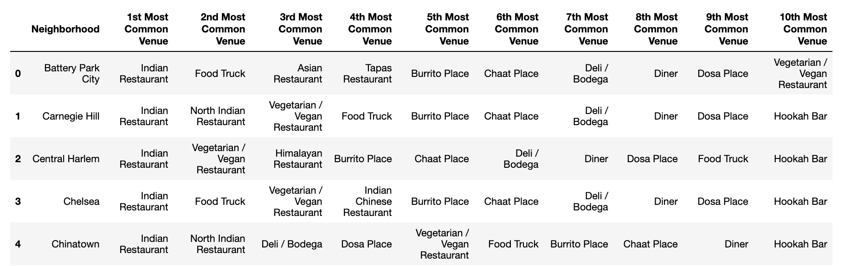

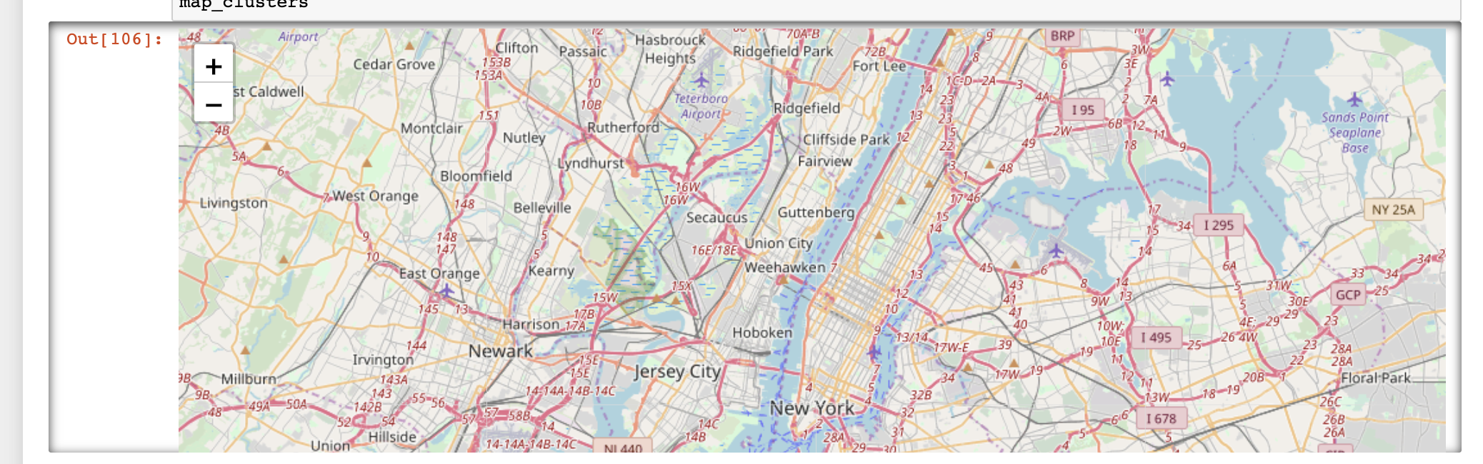

1. **Results**

**K-mean Cluster** Using K-mean to clustering data area with less number of sushi bars

**Cluster 0** 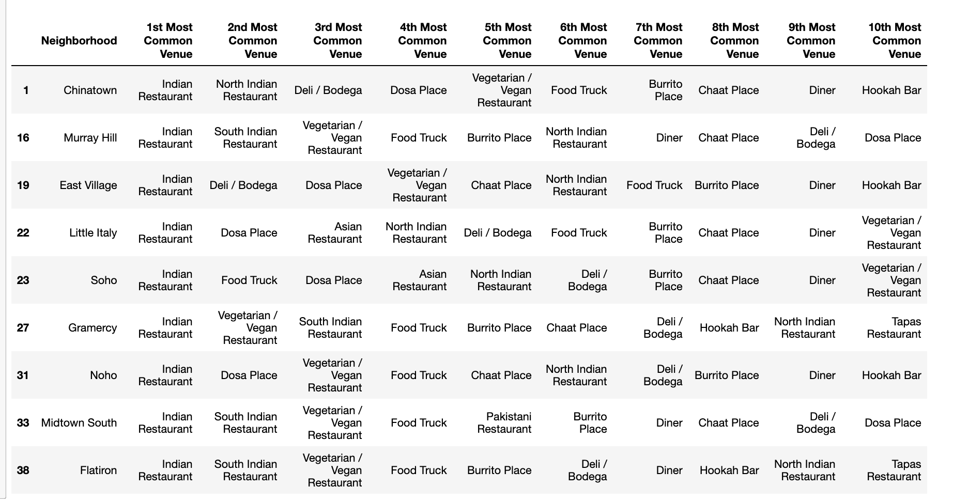**Cluster 1** 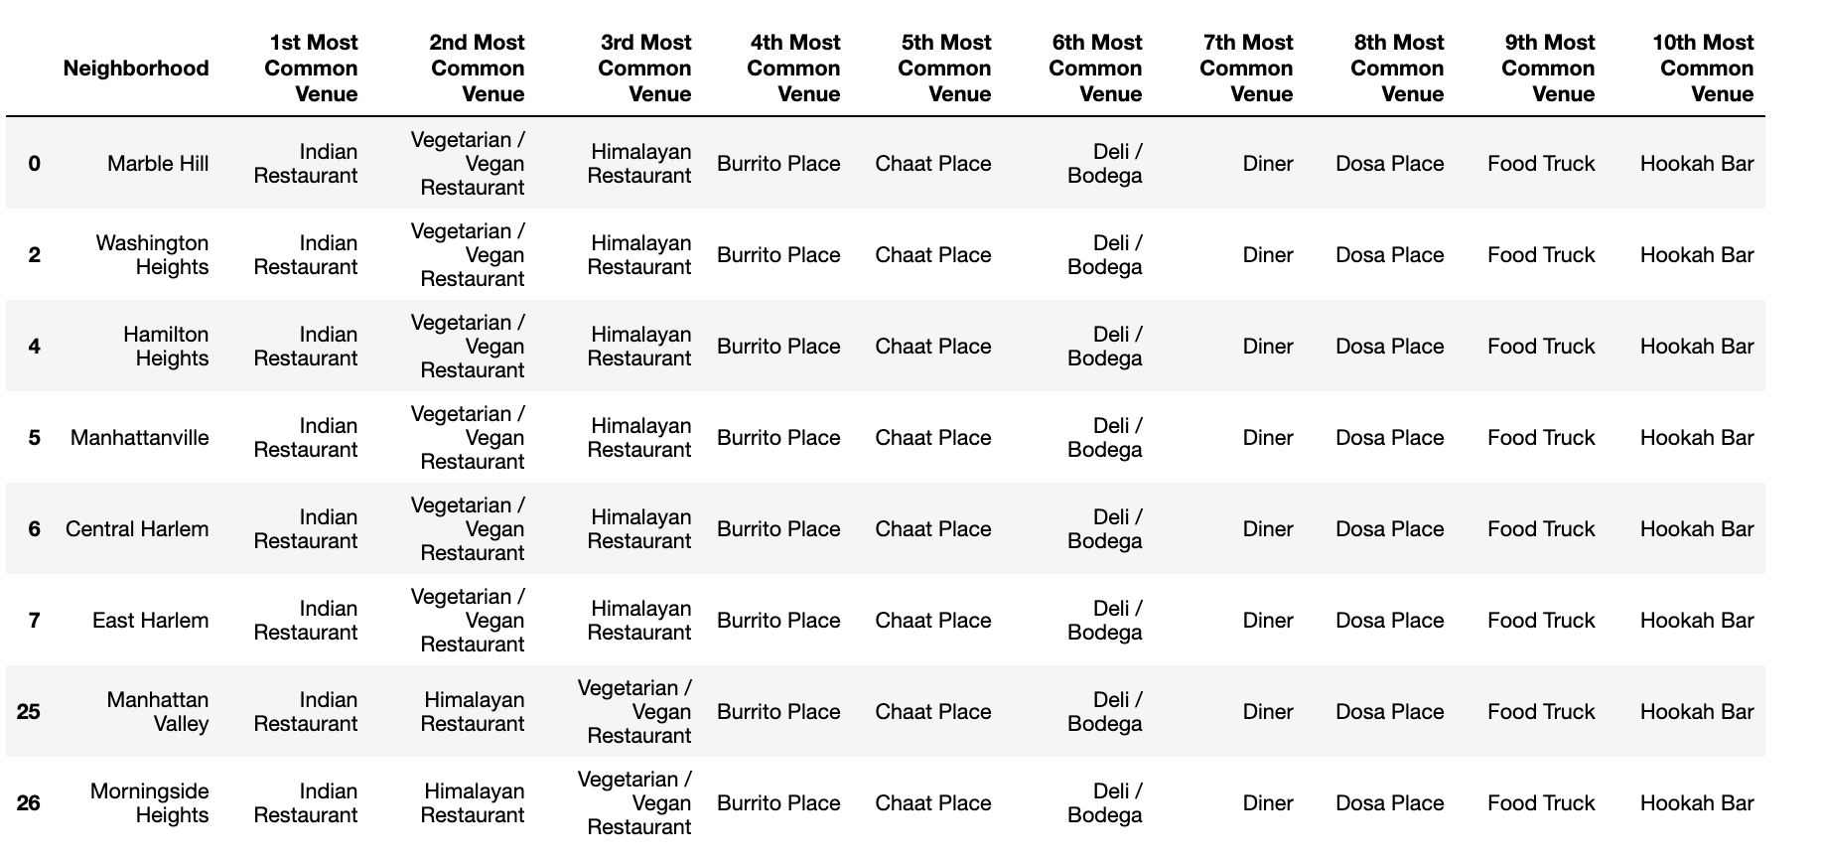

**Cluster 2** 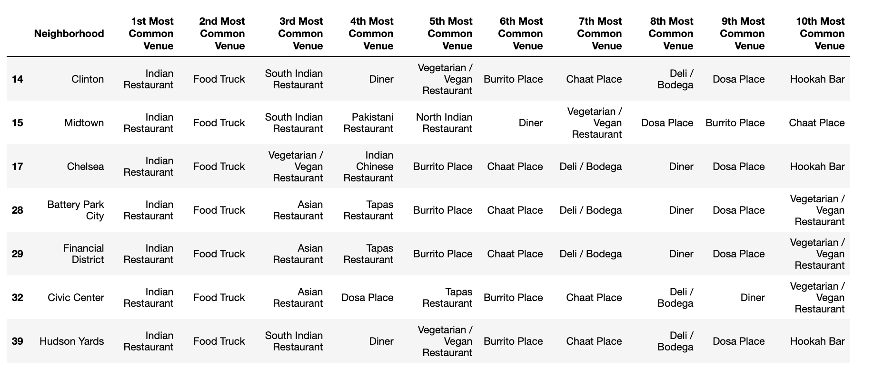**Cluster 3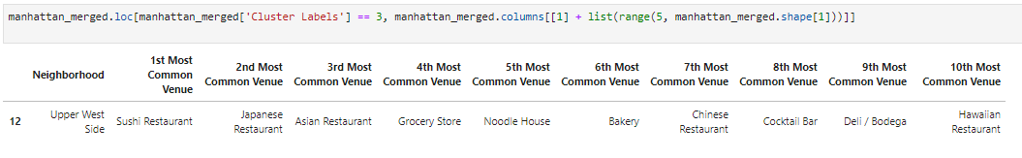Cluster 4**

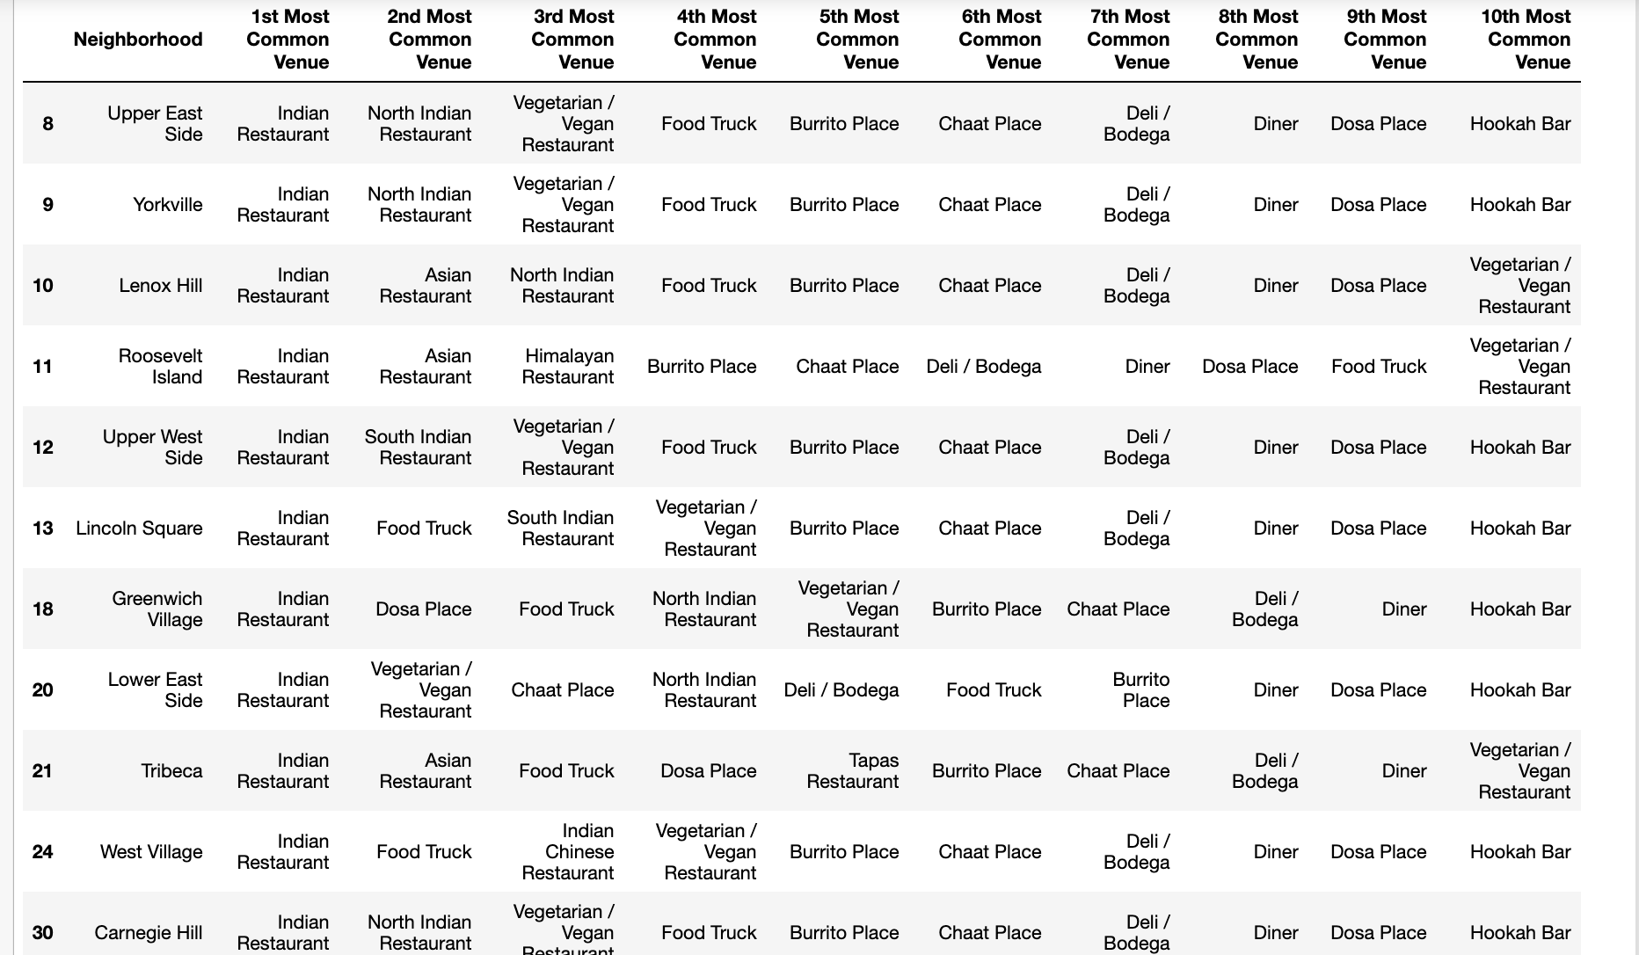

Based on dataframe analysis above Cluster 3 is the best places to open a new indian restaurant business.

1. **Discussion**

In this section, I would be discussing the observations I have noted and the recommendation that I can make based on the results.

Below are discussion points

There is high competition in other areas so risky tto open restaurant

It can be done more detailed analysis by adding other factors such as transportation, demographics of inhabitants.

FourSquare proved to be a good source of data Finally, FourSquare proved to be a good source of data but frustrating at times. Despite having a Developer account I regularly exceeded my hourly limit locking me out for the day

1. **Conclusion**

Although the project recommended the location but still there is room for improvement but still the goal to identify a location was made possible